**Directions:** Using the four prompts below, identify how the FoodieLand app demonstrates good UX design.

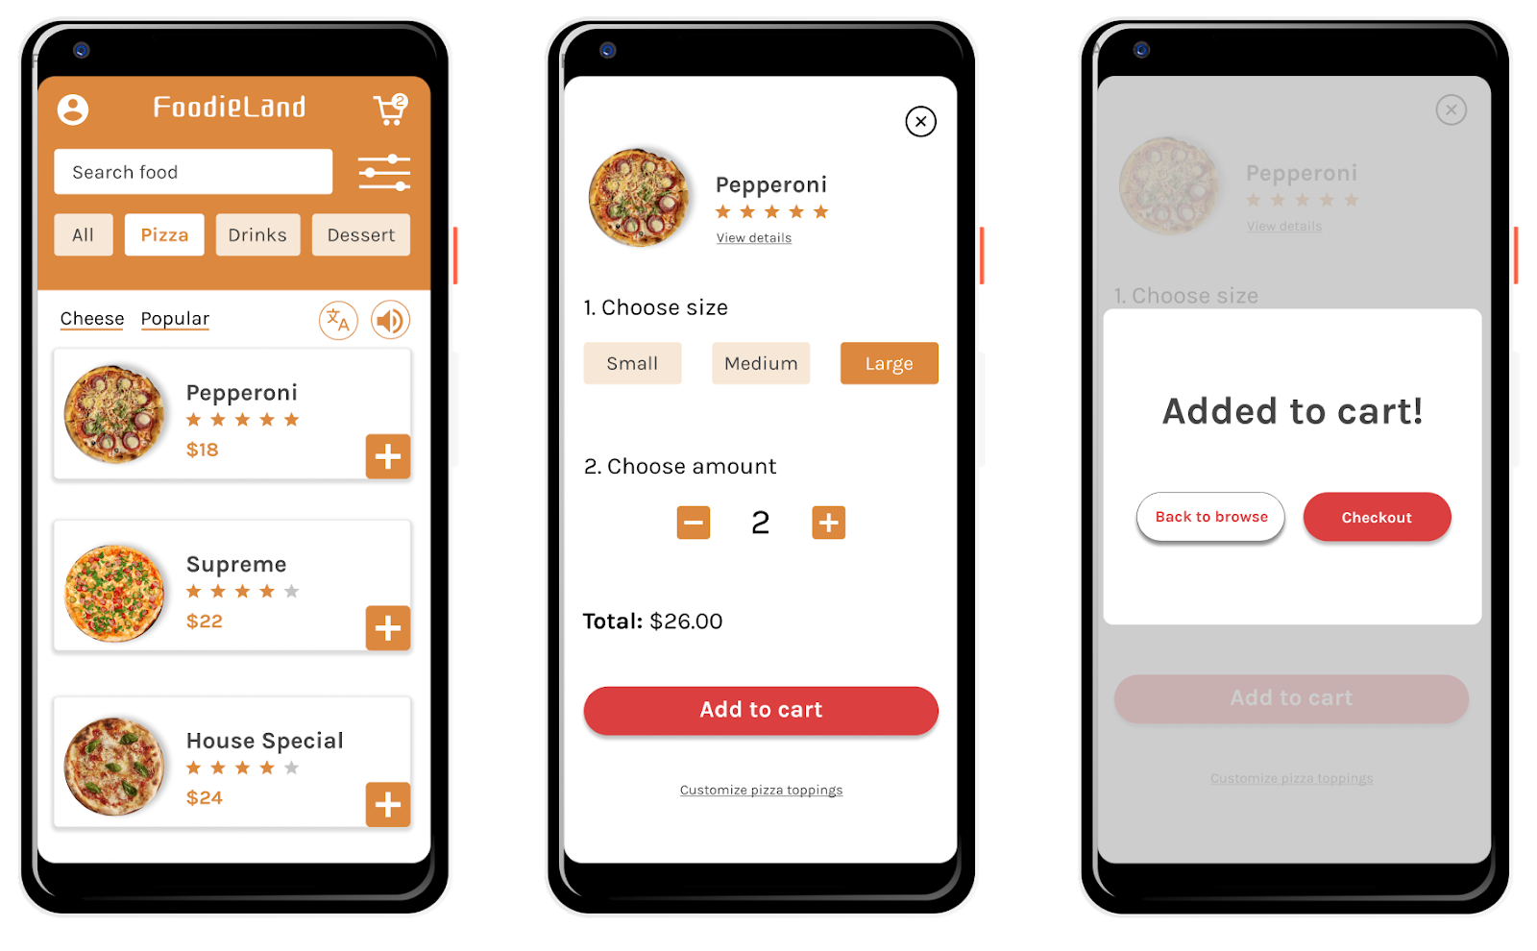

Prompt 1: Identify at least one aspect of the FoodieLand app that demonstrates usable design. Explain your reasoning in 1-2 sentences.

| Hint: Is the app’s design, structure, and purpose clear? Does the app have any elements or features that make it easy to navigate? | | |
| --- | --- | --- |

| **Usable** | The menu is adequate for the application and easy to use. There are no complications that may ruin the experience. |
| --- | --- |

## 

## Prompt 2: Identify at least one aspect of the FoodieLand app that demonstrates equitable design. Explain your reasoning in 1-2 sentences.

| Hint: Does the app address the needs of people with diverse abilities and backgrounds? | | |
| --- | --- | --- |

| **Equitable** | The customization options menu after selecting the pizza is really equitable as the users do not need to navigate through the pages to find the right ingredients. As few users may prefer to eat vegan. |
| --- | --- |

## 

## Prompt 3: Identify at least one aspect of the FoodieLand app that demonstrates enjoyable design. Explain your reasoning in 1-2 sentences.

| Hint: Does the app inspire a positive reaction from the user by considering their thoughts and feelings? Does the app engage users and make them excited to keep using the app? | | |
| --- | --- | --- |

| **Enjoyable** | Illustrating the pictures of the food provides the users with satisfaction of what they are getting. |
| --- | --- |

## 

## Prompt 4: Identify at least one aspect of the FoodieLand app that demonstrates useful design. Explain your reasoning in 1-2 sentences.

| Hint: Does the app solve the problem of “how to help a busy person working from home select a meal to be delivered?” How does the app help solve this problem? | | |
| --- | --- | --- |

| **Useful** | Filter, and cart being available on the front page is really useful for the users as it reduces time and makes the whole process faster. |
| --- | --- |